Referees information
Name: Prof. Simon Schultz
Relationship: Supervisor of master’s final project
Job title: Professor of Neurotechnology, Department of Bioengineering, Imperial College London
Email: s.schultz@imperial.ac.uk
Location: 4.11, 4th Floor, Royal School of Mines, South Kensington Campus, Imperial College London, SW7 2AZ

Name: Dr. Henry Lancashire
Relationship: Supervisor of undergraduate’s final project
Job title: Lecturer in Active Implanted Medical Devices, Department of Medical Physics and Biomedical Engineering, University College London
Email: h.lancashire@ucl.ac.uk
Tel: +44 (0)20 3108 1611 (Office)
Location: Room 8.03, Malet Place Engineering Building, University College London, Gower Street, London, WC1E 6BT

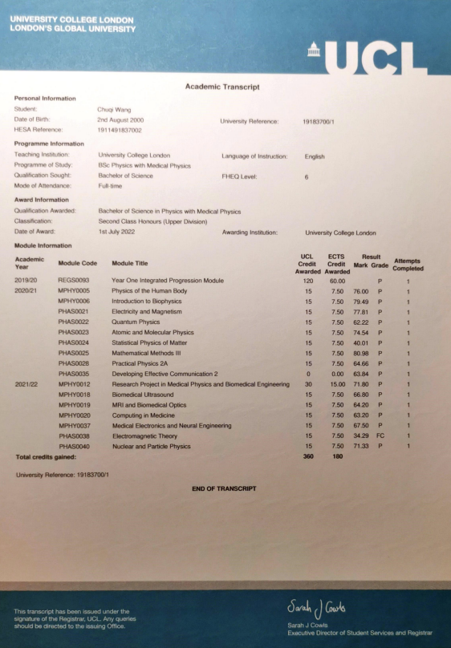

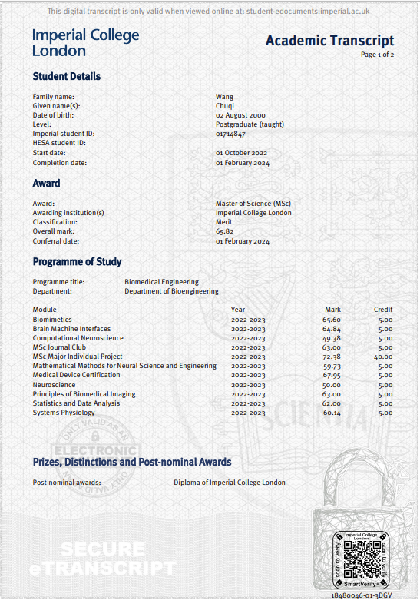

Dear Prof. Bizley and the recruitment team,
I am writing to confirm my willingness to self-fund or secure funding independently to cover the difference between the UK and the international rates.
Special Case: I am currently an international student residing in the UK on a graduate visa, valid until March 2026. However, I will reach my 10 years of residence in July 2025, making me eligible to switch to an Indefinite Leave to Remain visa. This change would likely make me eligible for the UK home rate if I enroll in September 2025. Therefore, my ideal offer would be to work as a Research Assistant in the lab for one year and enroll as a PhD student in 2025.
I would be happy to discuss my situation further and explore any potential flexibility regarding this opportunity, if I pass the initial stage of selection.
Thank you for considering my application.

Best regards,
Chuqi

Cover Letter
(copy of the Questionnaire section)
I am writing to express my keen interest in the role of research assistant with a PhD enrolment, to study and research on sound mapping in the brain. My background in medical physics and biomedical engineering, combined with my passion for neuroscience and cutting-edge research, has prepared me to contribute to this project and your esteemed research team.
Background and Research Interests
I hold a BSc degree in Medical Physics with Physics from UCL, where focused on studying the physics principles of advanced medical imaging and therapeutic techniques. My interest in neuroscience was sparked during my final project, which intended to build a wearable device to record and decode EMG signals and translate into sound signal. The purpose of the device is for auditory biofeedback application aimed at improving involuntary muscle control. This project presented challenges such as extracting meaningful features from physiological signals and mapping the features to the sound signals, which the auditory nervous system could process to generate correct motor outputs. The complexity of understanding these topics motivated me to purse a Master’s degree, where I delved deeper into novel technologies in neuroscience. I realised that a comprehensive understanding of mechanisms, study models, and data analysis techniques is crucial for success research in neuroscience, which request a long-term progress, and this realisation drives my desire to pursue a PhD.
Knowledge, Skills and Experience
Throughout my academic journey, I have built a strong foundation in both biological mechanisms and advanced technology in neuroscience. I have developed programming skills and gained a deep understanding of the nervous system, from molecular to system level. My coursework included mathematical methodologies for modelling biological systems and analysing complex neural data, such as time series analysis, graph theory and general linear model. Additionally, I acquired computational skills to construct neuron-level and neural network models, and decoded and processed neural data for application in Brain-Machine Interfaces.
My research skills have been honed through various projects and internships. In my undergraduate project, I gained experience with electrophysiological signal recording, and signal filtering circuit design. Using Arduino, I programmed for real-time data processing. My master’s project involved investigating the morphology and neural dynamics of cerebral organoids under temperature changes. I cultured 3D organoids derived from induced pluripotent stem cells, and performed calcium imaging using a two-photon microscope. These experiences provided me with hands-on skills in wet lab techniques and advanced microscopy. During a summer internship, I worked on a new GUI for high-intensity focused ultrasound (HIFU) hardware, conducting calibration experiments and creating a user guide. This experience sharpened my experimental design, data collection, result validation, and problem-solving skills. I believe the technical and practical experience I have gained from my previous projects would be transferable to this opportunity.
Personal Skills
Working in various laboratory environments has heightened my awareness of potential hazards and reinforced my commitment to safety and responsibility. My previous role as a research assistant honed my decision-making and communication skills, involving regular discussions with team members and supervisors.
Experience of leading a team for a journal club presentation during my Master’s study enhanced my teamwork and collaboration abilities, demonstrating that efficient communication and collaboration are essential for the success. I am committed to overcoming research challenges and understand that this process requires continuous learning and dedication.
Research vision
Neuroscience is a broad field with numerous intriguing questions to answer. There are diverse methods, technologies, and approaches. The study of sensory systems, like the auditory system, provides a fundamental understanding of how sensory inputs are processed and how signals interact across different systems, such as the visual and motor systems. This research offers insights into higher-level brain functions like attention, plasticity, and behaviour. Additionally, advancements in neuroscience and the development of novel technologies have the potential to unlock the brain's capabilities and improve our understanding of various pathologies. With the rapid growth of AI and machine intelligence research, I am enthusiastic about discovering the power of the human brain and how understanding neural circuits can contribute to breakthroughs in artificial intelligence. Just as biomimetics has led to successful engineering applications, I believe that exploring the brain's neural networks will advance artificial neural networks and technology. Researching the auditory system at your lab will provide a strong foundation and clear direction for my personal research journey.

Thank you for considering my application. I look forward to the opportunity to contribute to and learn from the vibrant research community in your lab.

